AgriTwin-GH: Agricultural Digital Twin for Greenhouse Horticulture of Tomato and Strawberry Cultivation

1st Amala Margret.A
Department of Information Technology
Puducherry Technological University
Puducherry,
2501712001@ptuniv.edu.in

4th Vantapati Raja Rajeswari
Department of Information Technology
Puducherry Technological University
Puducherry, rajarajeswari.vantapati261@ptuniv.edu.in
2nd Dr.V.Govindasamy
Department of Information Technology
Puducherry Technological University
Puducherry,
vgopu@ptuniv.edu.in

5th Bhuvanalashmi JP
Department of Information Technology
Puducherry Technological University
Puducherry
bhuvanalakshmijp329@ptuniv.edu.in
3rd Arjun Christopher
Department of Information Technology
Puducherry Technological University
Puducherry,
arjun.christopher877@ptuniv.edu.in

Abstract— Greenhouse production of high-value crops such as tomatoes and strawberries necessitate careful environmental control to achieve high yield, quality, and early disease prevention. This paper introduces AgriTwin-GH, a software-oriented, AI-driven digital twin solution for intelligent greenhouse management focusing on high-value crops like tomatoes and strawberries. The solution combines various tabular time-series greenhouse data and plant image datasets, including the Greenhouse Plant Growth Metrics Dataset, Smart Agriculture Dataset, Plant Village Dataset, Tomato Plant Stages Dataset, and Ripe Strawberries Detection Dataset. Disease identification from leaf images is done using Convolutional Neural Networks (CNNs), while growth prediction and future risk identification are done using Recurrent Neural Networks (RNNs). Environmental and crop parameters like temperature, humidity, CO₂ concentration, light intensity, soil moisture, pH, and nutrient levels are analyzed to calculate important parameters like vapor pressure deficit and disease risk indices. Short-term forecasting models predict future greenhouse conditions, which are validated using a digital twin in combination with a Model Predictive Control (MPC) strategy to produce optimal and safe-verified control decisions. The solution offers disease-informed predictions, growth stage information, and brief non-verbal operational notifications, facilitating efficient, scalable, and user-friendly smart greenhouse management. By facilitating early disease risk identification and optimized resource use, the proposed solution greatly improves crop productivity while minimizing waste of water, energy, and fertilizers. In summary, AgriTwin-GH provides a scalable and cost-efficient decision-support system for precision greenhouse horticulture, especially in labor-intensive and resource-scarce farming environments.
Keywords— Digital Twin, Smart Greenhouse, Time-Series Dataset, Plant Image Dataset, CNN, RNN, Model Predictive Control, Disease Prediction, Precision Agriculture.

Introduction
Greenhouse cultivation has become essential in modern agriculture because of increasing food demand, changing climate, and the need for consistent, high-quality production throughout the year. Unlike open-field farming, greenhouses create controlled environments where temperature, humidity, light intensity, and carbon dioxide levels are managed to promote plant growth. This is particularly important for high-value crops like tomatoes and strawberries, which are sensitive to environmental stress and disease. By providing stable growing conditions, greenhouse systems boost productivity while reducing environmental impact. Successful greenhouse production relies on precise environmental control and timely decision-making. Tomatoes and strawberries need specific ranges for temperature, humidity, soil moisture, nutrient levels, and light exposure, and these requirements change as the plants grow. Even slight deviations can lower yield, affect fruit quality, and increase the risk of diseases like powdery mildew, leaf mold, and leaf scorch. Unstable environments can also influence fruit firmness and shelf life, making consistent conditions crucial for both agronomy and economics.
Traditionally, greenhouse management is often reactive, depending on manual observations and periodic checks. Most interventions occur only after symptoms appear, leading to delays and potential overuse of water, energy, fertilizers, and chemicals. Decisions usually rely on the operator's experience, and historical data is not fully used to anticipate seasonal trends or disease risks.
Modern greenhouses function as interconnected systems with climate control, irrigation, ventilation, and lighting. Changes in one part affect the others, so basic rule-based control is not enough. External weather changes, sensor noise, and biological variability create a need for adaptive and dynamic management.
Using data-driven analysis enables early detection of negative trends in plant growth, disease onset, and resource use, supporting preventive measures. Virtual greenhouse models allow for the testing of environmental strategies before real implementation, enhancing reliability and enabling proactive intervention. Human-centered interaction is also key, especially in situations where workers may have limited literacy; simple visual or auditory alerts can improve usability and safety. Scalability matters too, as greenhouse facilities come in various sizes and with different technologies.
To tackle these challenges, AgriTwin-GH is introduced as a software-based intelligent greenhouse management framework specifically for tomato and strawberry cultivation. By combining data analytics, virtual modeling, and predictive decision support, it aims to improve early risk detection, optimize resource use, and enhance overall sustainability and yield.

LITERATURE SURVEY
Rawan Al-Najadi et al. provide a comprehensive review of recent developments in intelligent and autonomous greenhouse systems, focusing on the integration of Internet of Things (IoT), Artificial Intelligence (AI), Machine Learning (ML), Deep Learning (DL), and robotics. The study addresses challenges such as climate variability, shrinking arable land, and increasing food demand, highlighting the importance of controlled environment agriculture. The review analyzes over 100 research articles published between 2020 and 2025, categorizing them into applications including climate control, disease detection, yield prediction, and robotic automation. The findings show that IoT-enabled sensor networks combined with AI-based decision-making improve energy efficiency, water conservation, and crop productivity. However, limitations such as sensor fusion complexity, limited datasets, computational overhead, and lack of real-world deployment are identified, emphasizing the need for fully integrated autonomous greenhouse frameworks rather than isolated implementations [1].
Daniel Anthony Howard et al. propose an Industry 4.0–based Digital Twin framework for commercial greenhouse systems. The approach digitally replicates physical greenhouse operations to enhance monitoring, simulation, and optimization through IoT, cloud computing, big data analytics, and AI. This virtual representation enables data-driven decision-making without disrupting real-world operations. The framework integrates multiple specialized Digital Twins modeling climate, energy consumption, production scheduling, and labor management. Simulation results demonstrate co-optimization of energy usage, productivity, and operational cost while maintaining crop quality. The study also highlights the potential for smart grid integration, establishing a scalable foundation for large-scale digital greenhouse management [5].
Abdellatif Soussi et al. introduce a greenhouse management system combining Digital Twin technology with Model Predictive Control (MPC) to achieve adaptive and sustainable climate regulation. The study addresses the limitations of rule-based control strategies by incorporating predictive modeling through a virtual greenhouse representation. A state-space model captures greenhouse thermal dynamics, and MPC regulates parameters such as temperature, ventilation, shading, and heating. Validation using multi-season meteorological data demonstrates stable climate maintenance, improved energy efficiency, and enhanced robustness. The results confirm that Digital Twin–based predictive control outperforms traditional static approaches [13].
B. V. Nikitha et al. explore machine learning techniques for early detection and classification of plant leaf diseases, aiming to reduce crop loss through automated diagnosis. The study evaluates Support Vector Machine (SVM), K-Nearest Neighbor (KNN), and Convolutional Neural Network (CNN) models using a soybean leaf disease dataset. After image preprocessing and feature extraction, experimental results show that CNN achieves the highest accuracy (96%), outperforming SVM and KNN. While demonstrating the effectiveness of deep learning for disease detection, the study highlights challenges related to computational demands and the requirement for large labeled datasets [10].

EXISTING SYSTEM
The current system serves as a baseline. It combines an AI-based agriculture support module with a simple greenhouse visualization. Instead of a full control-oriented twin, it mainly shows how key greenhouse readings can be displayed live. AI models provide advisory outputs, such as identifying diseases from images and recommending crops based on data inputs.
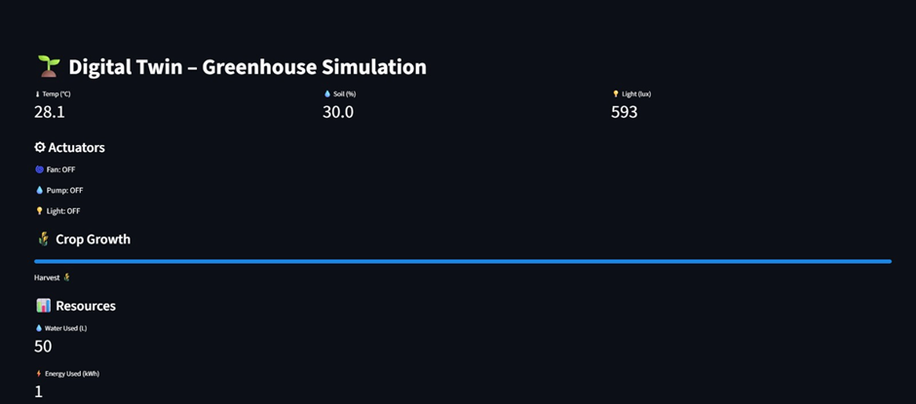Fig. 1. Real-Time Greenhouse Simulation Dashboard
Fig. 1. illustrates the greenhouse simulation dashboard. It continuously displays a small set of core parameters: temperature, soil moisture, and light intensity. These are the main indicators of the greenhouse's state. The same screen also shows the status of common greenhouse devices like fans, pumps, and lights, indicating whether they are ON or OFF. This helps users see if ventilation, irrigation, or lighting is in use at that moment. The interface features a simple crop growth indicator presented as a single progress bar. This bar has a harvest marker to represent crop development in a general way, without detailing each growth stage. Additionally, the dashboard monitors basic resource usage metrics like water and energy consumption. This information helps summarize operational usage but does not connect these values to optimization goals or decisions based on constraints.
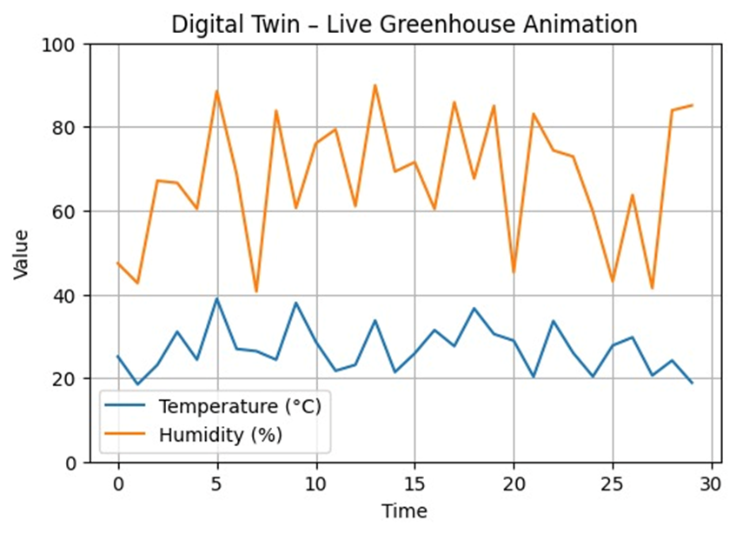
Fig. 2. Live Time-Series Visualization of Greenhouse Temperature and Humidity Dynamics
To support the idea of continuously changing greenhouse conditions, Fig. 2. illustrates a live time-series visualization of temperature and humidity. The plotted curves show that the system can generate or stream evolving environmental values over time, giving users a quick view of fluctuations and variability. This is important since greenhouse management depends on understanding trends instead of single readings. However, the visualization remains descriptive and does not indicate the use of forecasting, what-if simulation, or predictive control. In particular, though humidity is displayed as a key factor, the system presentation does not show derived greenhouse decision metrics like vapor pressure deficit, dew point, or cumulative high-humidity duration. These metrics are often needed for managing disease risk in controlled environments.
Alongside this visualization layer, an image-driven disease identification model, and a crop recommendation module. The disease component uses a CNN-based classifier that processes a leaf image through standard preprocessing, which includes resizing and normalization. It outputs the most likely disease label along with a confidence score. The crop recommendation module applies traditional machine learning to soil and environmental data to suggest a suitable crop label. In the baseline setup, these AI modules serve as decision-support tools that can be included in a web interface, but they do not closely connect to the greenhouse simulation visuals. This limits the integration of environment sensing, risk prediction, and automatic actions.
Overall, this system serves as a dashboard for greenhouse monitoring and demonstration, enhanced by AI advisory models. It offers (i) insight into several environmental parameters and actuator states (Fig. 1.), and (ii) basic trend visualization for essential climate variables (Fig. 2.). Together, these features create an initial digital picture of greenhouse conditions. However, it does not represent a complete digital twin that aligns a greenhouse model with continuous multi-sensor data, tests actions through simulations, or optimizes actuator commands considering crop stages and disease risks. These features make it a suitable baseline for comparing with a greenhouse-focused digital twin framework that goes beyond visualization into prediction, validation through simulation, and resource-aware control.

PROPOSED WORK
This section describes the method used for the proposed AgriTwin-GH. The approach combines open-source data collection, AI-based analysis, and a digital twin-driven predictive control system to support smart, sensor-independent greenhouse management. The overall strategy is modular, based on data, and validated through simulation. It ensures scalability, safety, and real-world use.

Overall Architecture Diagram
The proposed method follows a layered and sequential workflow. Fig. 3. shows the overall structure of the AgriTwin-GH framework. This figure illustrates the entire data flow, starting from the collection of raw environmental and image data. It then moves through essential processing and intelligence modules and ends with actionable decision signals for the greenhouse.
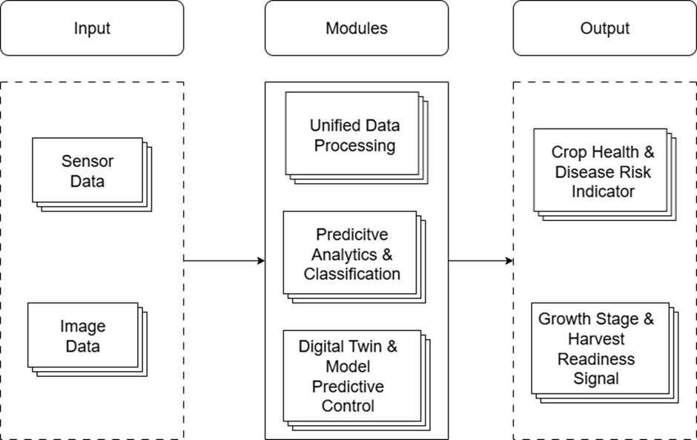Fig. 3. High-Level Architecture Diagram for Proposed Work
At a high level, the methodology consists of three tightly coupled stages:
- Unified data acquisition and preprocessing,
- Predictive analytics and crop intelligence generation, and
- Digital Twin and model predictive control.
These stages operate in a continuous feedback loop, enabling real-time system state updates and adaptive decision refinement.

Data Acquisition and Unified Processing Methodology
The first stage of the methodology focuses on transforming heterogeneous agricultural datasets into standardized, machine-interpretable representations suitable for advanced analytics and simulation.
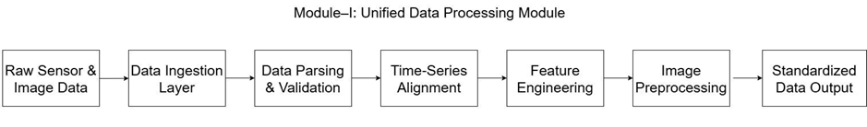Fig. 4. Module-Level Workflow of Unified Data Processing
As shown in Fig. 4., the Unified Data Processing module sets up a clear pipeline that starts with the collection of raw environmental time-series data and plant image datasets from open-access greenhouse repositories. These datasets mimic real greenhouse sensor streams and visual observations, allowing for tests without needing physical sensors.
The process begins with data ingestion and parsing, where different dataset formats are turned into a single internal format suitable for analysis. Next, data validation and cleansing take place. This step addresses missing values, removes outliers, and corrects noisy measurements commonly found in agricultural datasets. To keep multiple environmental variables consistent, we perform temporal data synchronization, aligning parameters like air temperature, relative humidity, carbon dioxide concentration, soil moisture, electrical conductivity, and pH levels.
After that, we carry out feature engineering and normalization. This involves extracting and scaling important indicators, such as trend patterns, rolling averages, and stress proxies, to ensure comparability across variables. At the same time, image preprocessing techniques, including resizing, normalization, and feature extraction, are used to create model-ready visual representations of crop conditions. By standardizing both numerical and visual data streams, this stage lays a solid and consistent foundation for future predictive modeling and digital twin simulation.

Predictive Analytics and Crop Intelligence Generation
The second stage of the methodology constitutes the analytical core of the system. As depicted in Fig. 3, the Predictive Analytics and Classification module converts preprocessed and normalized data inputs into actionable crop insights by leveraging both traditional machine learning methods and advanced deep learning models.
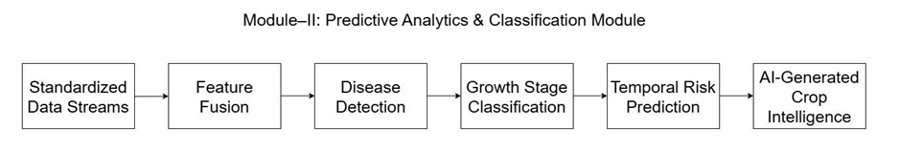
Fig. 5. Module-Level Workflow of Predictive Analytics & Classification
Integrated data processing approaches combine real-time readings from environmental sensors with visual features from plant images. This allows the system to generate a more complete and context-aware evaluation of greenhouse conditions. The outputs include continuously updated intelligence signals that represent both current and predicted crop states. These signals are not directly used; instead, they are sent to the digital twin layer for validation and optimization. The module uses supervised learning and temporal modeling algorithms to generate crop intelligence.
Disease Detection: The system identifies diseases through image-driven techniques using deep learning, specifically Convolutional Neural Networks. These networks excel at visual analysis because they automatically learn layered features from raw leaf images. They capture visual traits such as surface texture variations, discolored areas, and abnormal lesions. The model is trained on annotated datasets of tomato and strawberry leaves to recognize conditions like powdery mildew and leaf mold. Instead of giving simple yes/no answers, the classifier provides probability-based confidence values for each disease category. This probabilistic approach allows for early-stage risk assessment rather than late-stage confirmation. To improve prediction reliability, the visual results are interpreted alongside environmental factors like temperature and humidity, which helps ensure more context-aware and stable disease inference.
Growth Stage Classification: Supervised classification algorithms use both image features and historical environmental trends to distinguish the stages of plant development. The resulting stage-aware information supports flexible control strategies within the digital twin.
Temporal Risk Prediction: Time-series models analyze sequential dependencies to forecast short-term disease outbreaks and environmental stress. By examining sensor trends and recent visual cues, the system predicts imminent risks, which allows for proactive intervention.
Feature Fusion Strategy: The feature fusion process combines environmental data and image-based features into a single representation before classification and prediction. This approach improves prediction accuracy by linking observable plant symptoms with related environmental factors, enhancing the credibility and reliability of the analysis sent to the digital twin system.

Digital Twin and Model Predictive Control
The third stage of the methodology implements a software-based digital twin coupled with Model Predictive Control (MPC), as illustrated in Fig. 4. This module represents a virtual replica of the greenhouse system constructed using learned system dynamics and historical data patterns.
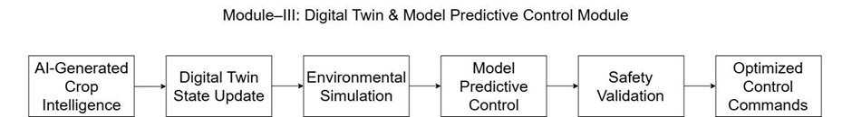
Fig. 6. Module-Level Workflow of Digital Twin & Model Predictive Control
The digital twin keeps a real-time virtual version of the greenhouse environment by constantly adding AI-generated crop insights. With this virtual model, the method simulates how the environment changes with different control strategies. These include adjusting irrigation, ventilation, lighting, humidity control, and temperature management.
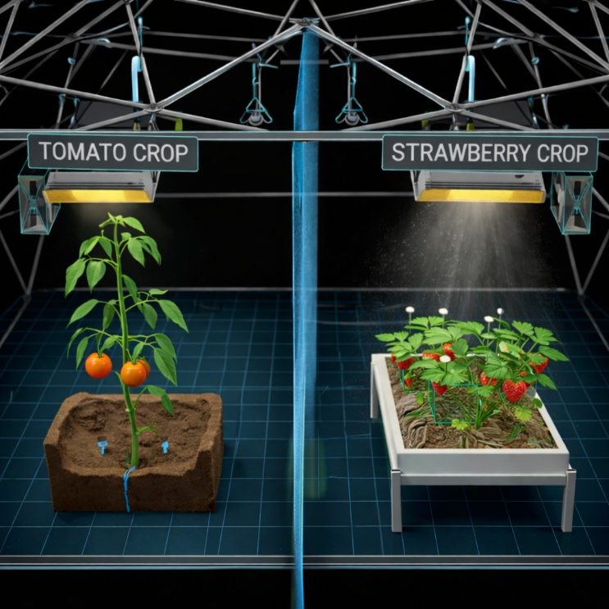
Fig. 7. 3D Conceptual Model of AgriTwin-GH Smart Greenhouse
Fig. 7. shows the proposed 3D structure of the AgriTwin-GH greenhouse framework. This design allows for the simultaneous cultivation of tomatoes and strawberries in controlled, separate environmental zones. The model clearly displays how crop environments are divided within a single greenhouse dome, showing the system’s ability to manage different crop needs at the same time.
The left chamber is for tomatoes, which grow in a soil-based substrate. It features moisture control and drip irrigation channels. The right chamber is for strawberries, which are grown in a raised bed system. This area has its own lighting and microclimate control.
LED grow lights hang above both crop zones. Actuators, including ventilation fans and irrigation emitters, are shown as parts that can be controlled. The central vertical partition illustrates the environmental isolation method that stops the climate settings meant for each crop from interfering with one another. This 3D model connects the idea of a digital twin framework with its actual greenhouse implementation. It highlights the segmentation of environments, the integration of actuators, and the adaptability for each crop.
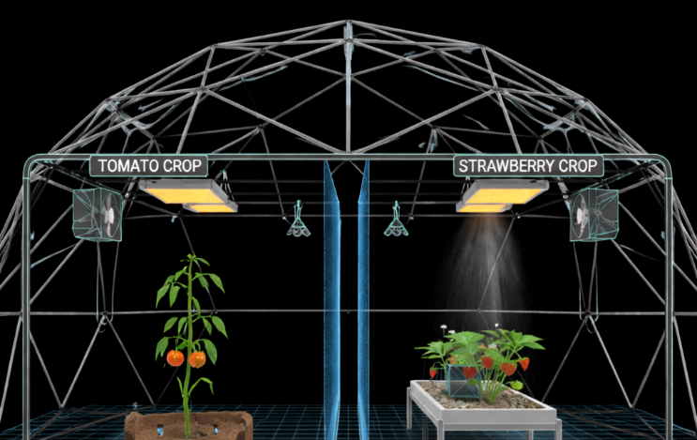
Fig. 8. Expanded 3D Greenhouse Structure Showing Integrated Actuation and Climate Control Components
Fig. 8. shows the complete structure of the intelligent greenhouse. It includes the dome framework, environmental control setup, and actuator positions within the AgriTwin-GH system. This figure emphasizes how climate control elements, like lighting modules, ventilation fans, humidity emitters, and sensor nodes, fit into the greenhouse canopy. The mesh dome acts as the physical enclosure, while the internal grid floor represents the digital twin mapping used for environmental simulation and tracking parameters. The dual-zone setup shows the system’s ability to manage crop-specific control loops under a single supervisory structure. Each actuator connects logically to the digital twin layer. This setup allows for real-time simulation, predictive assessment, and improved control validation before deployment. The figure highlights the main idea of AgriTwin-GH: a unified integration of the physical greenhouse and a software-driven digital twin with a predictive control system.
Model Predictive Control is a strategy based on real-time optimization. It predicts how a system will behave in a set future period. It looks at different control inputs using a cost function and picks the best action at each step with a rolling time frame.
In the digital twin framework, the MPC module finds the best operational settings for the greenhouse. This includes timing for irrigation, control of ventilation, lighting intensity, humidity management, and temperature stabilization.
Before considering any recommendation valid, the method does simulation-based safety checks. This ensures that suggested actions do not breach crop safety levels or environmental stability. This step greatly lowers the risks tied to data-driven control decisions.
The objective function aims to keep plants healthy, reduce their vulnerability to disease, and efficiently use water and energy. It also follows agronomic and safety guidelines. Before putting actions into practice, proposed control steps are tested through virtual simulations. This checks their effectiveness and stability. Once refined, these decisions are implemented as improved control directives.

Integrated Decision Support and System Behavior
The final outcome is a closed-loop, predictive decision-support system that continuously senses, predicts, simulates, and improves greenhouse operations. Rather than deploying actuators directly, the system creates interpretable decision signals, such as crop health indicators, disease risk alerts, growth stage identification, and harvest readiness signals. This approach shows a sensor-independent digital twin model, where open-source datasets act as virtual sensors. This enables scalable experimentation, lowers infrastructure costs, and allows for safe testing of intelligent control strategies.
By combining unified data processing, AI-based predictive analysis, and digital twin-driven model predictive control into a single framework, the proposed method goes beyond traditional greenhouse monitoring systems. It supports proactive, simulation-confirmed decision-making, early risk detection, and smart resource optimization. This creates a strong foundation for precision greenhouse horticulture.

EXPERIMENTAL ANALYSIS
The experimental evaluation was carried out using the AgriTwin-GH feature, where a multi-parameter greenhouse time-series was generated and processed to reproduce baseline monitoring behavior and then extend it with predictive analytics, risk-aware control, and outcome comparison.

Digital Twin Environment Modeling and Predictive Control
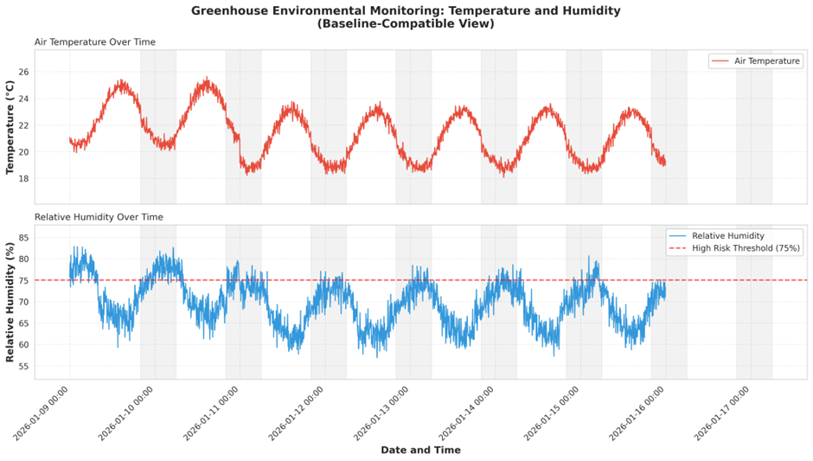
Fig. 9. Baseline-Compatible Temperature and Humidity Monitoring
Fig. 9 shows the environmental monitoring view that works with the baseline. It displays air temperature and relative humidity over time in a way that is common in traditional greenhouse dashboards. The temperature pattern has a consistent daily cycle with regular peaks and valleys, showing the changes between day and night. At the same time, the humidity curve shows the expected opposite trend compared to temperature, with a clear line marking a high-risk humidity level. This figure is designed to reflect how the existing system operates. It shows that AgriTwin-GH keeps the same basic feature of continuously tracking temperature and humidity, as well as providing visibility based on thresholds. This setup allows for a direct comparison with baseline monitoring solutions that mainly focus on visualization and simple limits.
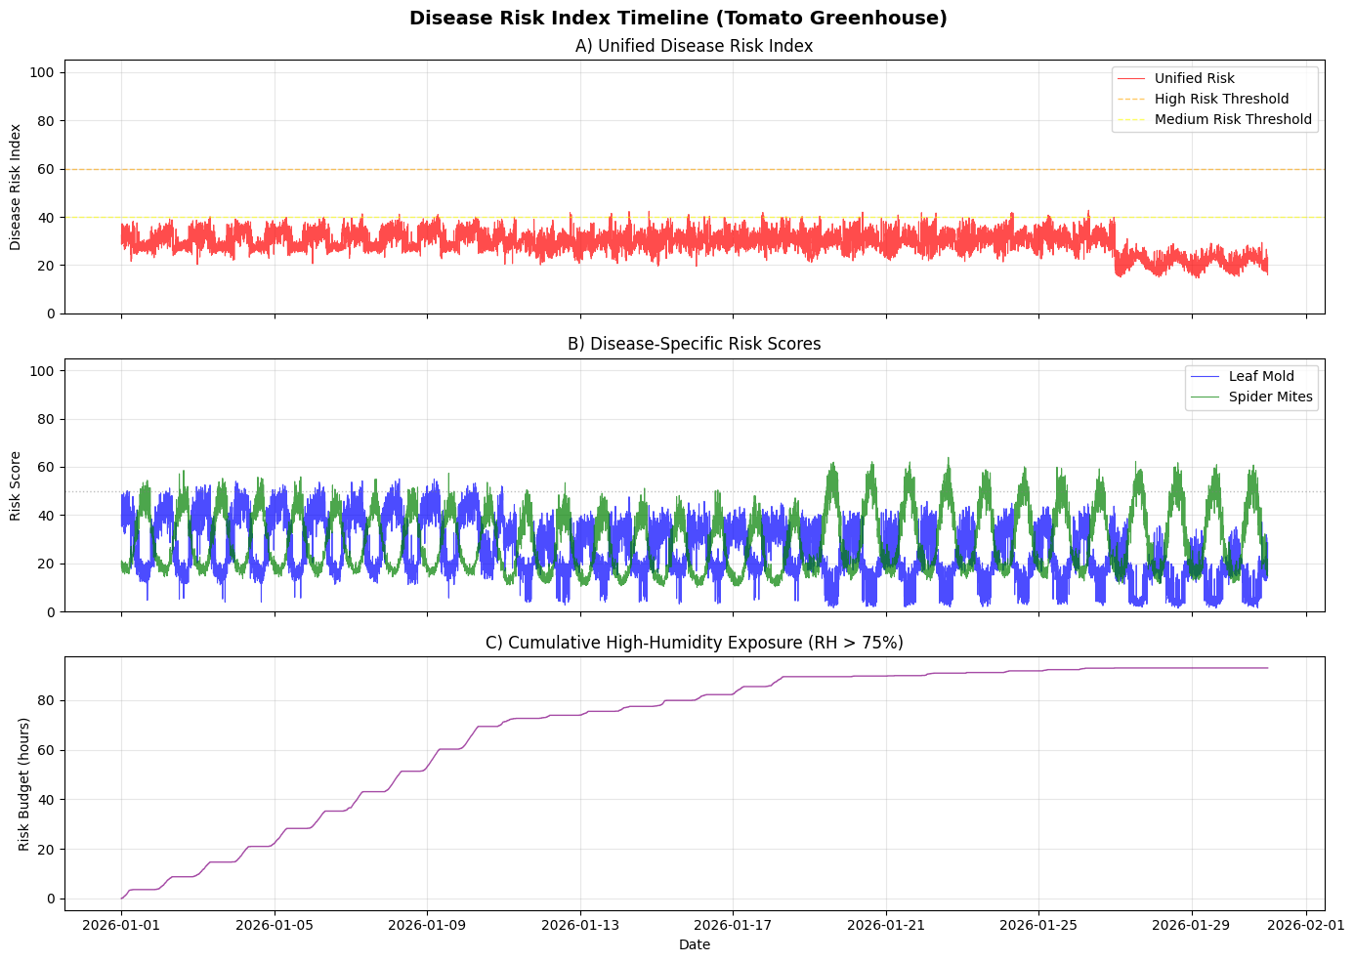
Fig. 10. Disease Risk Index and Exposure Analysis
Building on the baseline visibility, Fig. 10. reports the disease intelligence layer introduced in AgriTwin-GH through a risk indexing mechanism derived from environmental exposure patterns. Fig. 10(A) shows a unified Disease Risk Index, where the index mostly stays within the safe-to-moderate range. It is interpreted in relation to medium/high thresholds and highlights critical zones. Fig. 10(B) breaks down the unified index into disease-specific risk scores, such as leaf mold. This demonstrates that the system does not view “disease risk” as a single generic alarm; instead, it distinguishes risk signatures that arise under different environmental conditions. Finally, Fig. 10(C) summarizes cumulative high-humidity exposure, or risk budget. This captures stress over time rather than just immediate spikes. This is crucial for greenhouse pathology since sustained exposure is often more informative than single-point threshold crossings. In contrast, the existing monitoring approach shown in Fig. 9. reveals “what happened,” such as humidity crossing a line. Fig. 10. provides structured evidence of why it matters, including risk accumulation and what it implies, specifically disease-specific risk characterization, which becomes directly actionable for control decisions.
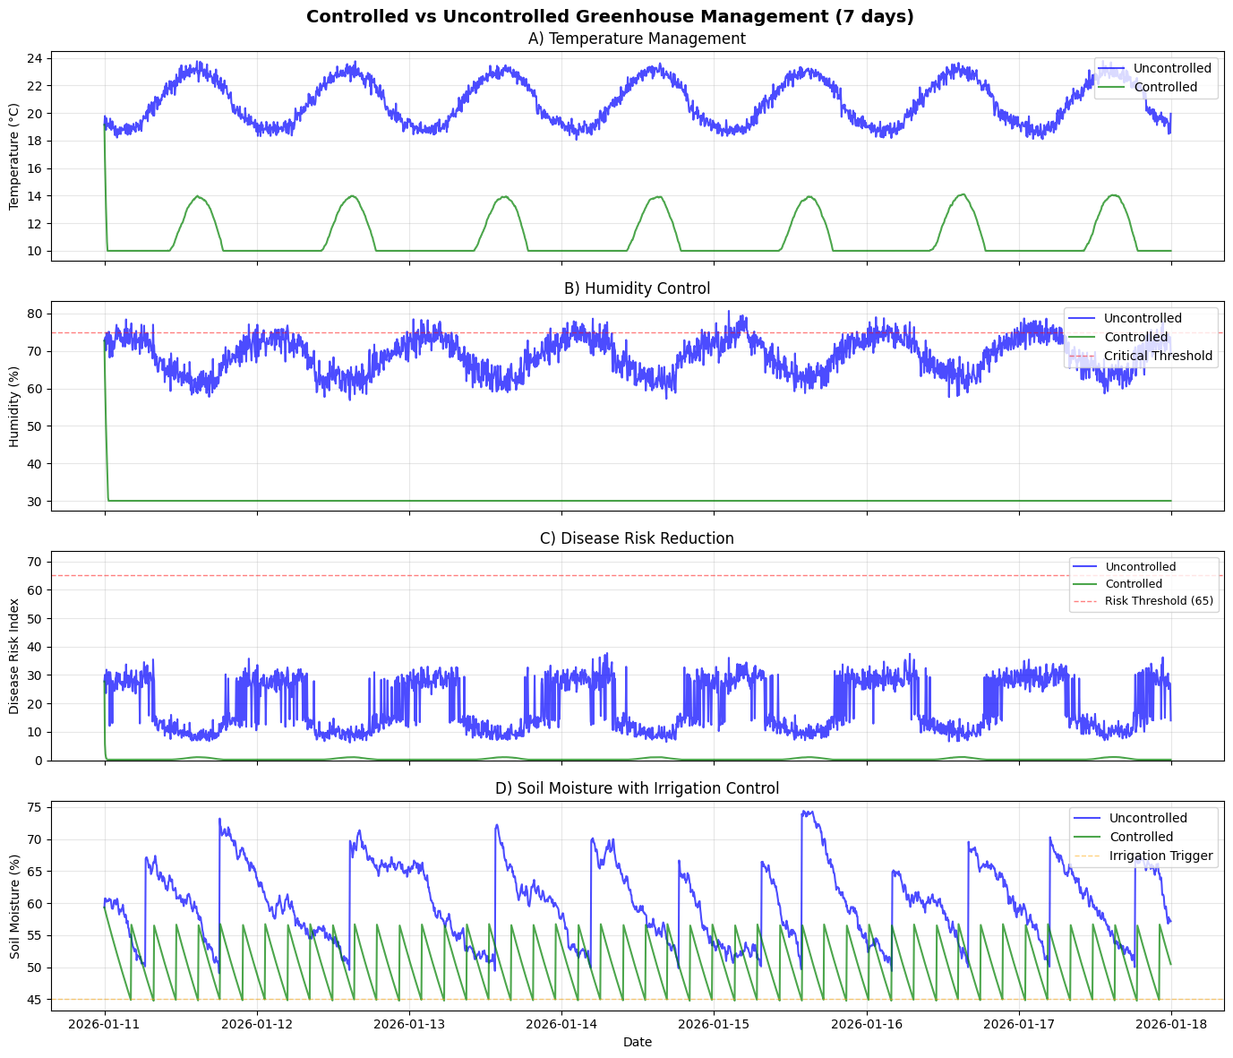
Fig. 11. Controlled vs. Uncontrolled Greenhouse Performance
Fig. 11. presents the main outcome comparison that sets AgriTwin-GH apart from baseline systems. It shows controlled and uncontrolled greenhouse management over a 7-day period. Fig. 11(A) indicates that closed-loop control produces a tighter temperature trajectory compared to the uncontrolled case. This reflects better setpoint tracking and less drift. Fig. 11(B) demonstrates humidity regulation in relation to the critical threshold. The controlled profile stays more consistently within the safe operating range. Fig. 11(C) connects these improvements to the intended goal by showing reduced disease risk under control. The controlled risk curve remains lower than the uncontrolled curve, preventing risk spikes. Fig. 11(D) enhances the climate and risk results by revealing soil moisture behavior with irrigation control. It shows how actuator logic stabilizes moisture around an operational threshold instead of causing wide fluctuations in depletion and recovery. Overall, this figure offers a clear, report-ready comparison. Baseline monitoring can only show deviations, while AgriTwin-GH shows measurable improvements in stability and risk management through a digital twin-informed control policy. This is essential for achieving a meaningful system outcome beyond simple visualization.

Disease Classification Performance and Visual Validation
To further validate the intelligence layer of AgriTwin-GH, disease prediction performance was evaluated using deep learning–based image classification. The model was trained to identify tomato and strawberry leaf diseases under multiple classes.
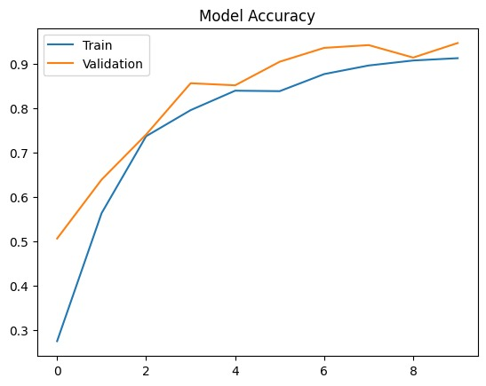
Fig. 12. Model Accuracy Convergence Curve
Fig. 12. shows how training and validation accuracy change over epochs during the training of the disease classification model. The training accuracy steadily approaches about 91%, while the validation accuracy nearly hits 97%. This suggests strong generalization and little overfitting. The similarity between the training and validation curves indicates stable learning and the robustness of the convolutional feature extraction process.
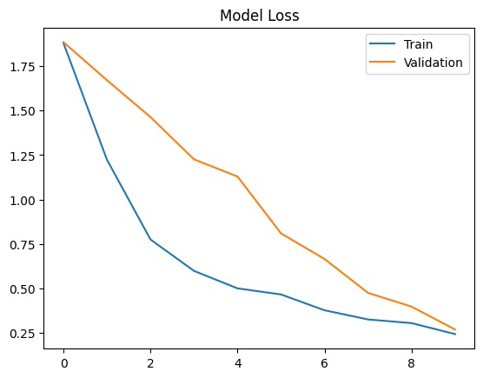
Fig. 13. Model Loss Convergence Curve
Fig. 13. shows the training and validation loss curves. A steady drop in both curves suggests effective optimization and convergence. The final validation loss is about 0.27, which shows a lower classification error and confirms the stability of gradient-based learning during model fine-tuning.
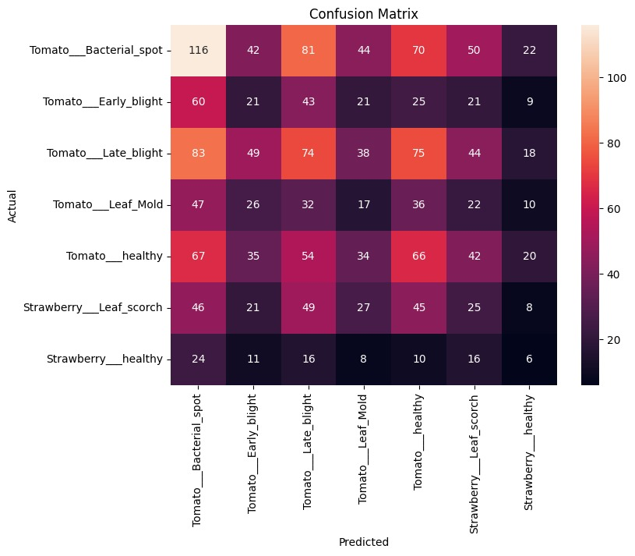
Fig. 14. Confusion Matrix for Multi-Class Disease Classification
Fig. 14. shows the confusion matrix that represents prediction performance for several disease classes, including Tomato Bacterial Spot, Early Blight, Late Blight, Leaf Mold, Healthy Tomato, Strawberry Leaf Scorch, and Healthy Strawberry. The matrix breaks down correct and misclassified samples for each class. It highlights strong performance in the main classes but also shows some confusion between visually similar disease categories. This visualization confirms the classifier’s ability to distinguish between classes and points out areas where the model can be improved.
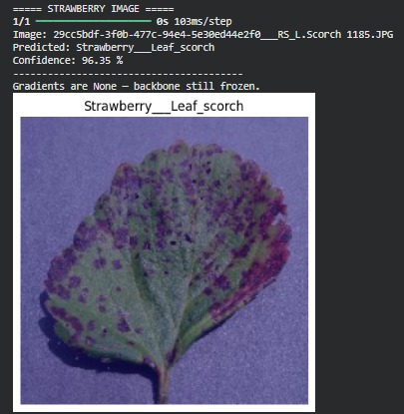
Fig. 15. Strawberry Leaf Scorch Prediction Example
Fig. 15. shows a strawberry leaf image identified as Strawberry___Leaf_scorch. It has a prediction confidence of 96.35%. This high confidence score highlights the model's skill in identifying detailed lesion patterns and areas of discoloration typical of fungal infection.
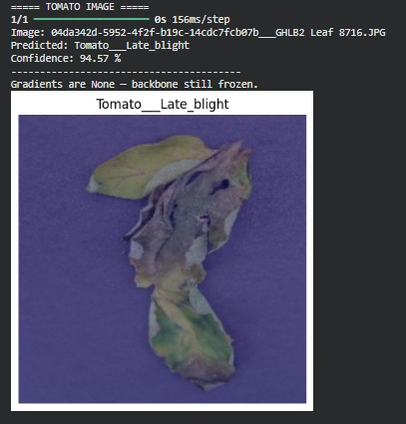
Fig. 16. Tomato Late Blight Prediction Example
Fig. 16. shows a tomato leaf sample identified as Tomato___Late_blight, with a confidence score of 94.57%. This result confirms that the model can successfully recognize disease-specific structural damage and necrotic patterns that are typical of late blight infection.

Growth Stage Classification Results
Growth stage classification was evaluated using the RandomForest-based temporal model implementation. The model integrates engineered environmental features such as day index, light integral, temperature statistics, soil moisture, and humidity to classify four developmental stages: Vegetative, Flowering, Fruiting, and Harvest.
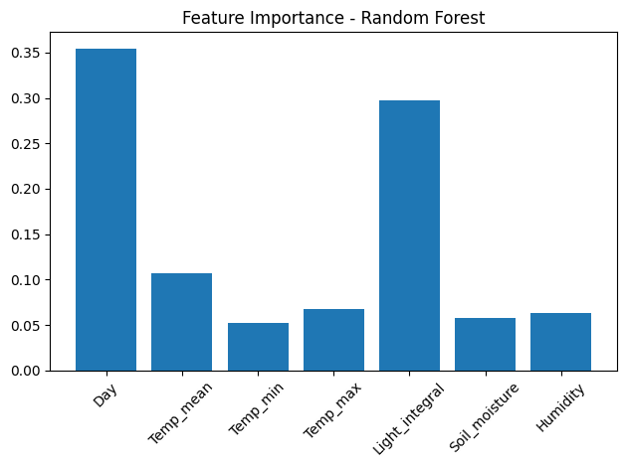
Fig. 17. Feature Importance Analysis
Fig. 17. shows the ranking of feature importance based on the optimized RandomForest classifier. The Day index and Light Integral are the top predictors, showing that time and total light exposure are key factors in crop development. Temperature measurements, soil moisture, and humidity have a secondary impact. This ranking supports the idea of agronomic consistency and shows that the model identifies meaningful physiological patterns instead of random correlations.
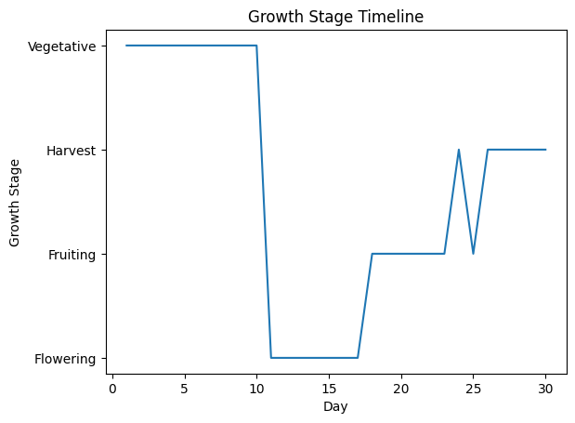
Fig. 18. Growth Stage Timeline Prediction
Fig. 18. illustrates the predicted growth stage timeline across a 30-day cultivation cycle. The model moves sequentially from Vegetative to Flowering, Fruiting, and then to Harvest, with minor changes linked to environmental variations. The timeline shows that stage classification matches the expected crop growth patterns and demonstrates flexibility within the digital twin framework.

Digital Twin Response to AI-Driven Crop Intelligence
The results from the disease prediction and growth stage classification modules are not seen as separate findings. Instead, they serve as active inputs for the digital twin environment. The digital twin keeps updating its internal representation of the greenhouse state. It uses disease probability scores from the CNN-based classifier, growth stage labels from the RandomForest temporal model, and environmental risk indices from time-series analysis. When the predicted disease probability exceeds predefined thresholds, the digital twin adapts its control strategy by incorporating a disease-risk penalty term into the Model Predictive Control (MPC) objective function:
$$J = \sum_{k=1}^{N}{\left(αE_{k}+ βR_{k}+ γD_{k}\right)}$$
In (1) E_{k} represents environmental deviation cost, R_{k} ​ denotes resource usage cost, D_{k} corresponds to the disease risk penalty derived from CNN outputs, and α, β, γ are weighting coefficients that regulate the influence of each component.
In parallel, growth stage classification directly affects control setpoints within the digital twin. During the vegetative stage, the system allows for higher humidity levels to encourage leaf biomass growth. In the flowering stage, the system enforces stricter temperature control to maintain reproductive stability. During fruiting, the irrigation schedule is adjusted to support fruit growth and quality. In the harvest stage, the control strategy focuses on maintaining environmental stability to keep fruit firmness and post-harvest quality. This stage-aware change allows the digital twin to shift from rigid threshold-based control to management that is sensitive to biological context and crop needs.
The integrated workflow therefore follows a structured progression: Prediction → State Update → Simulation → MPC Optimization → Controlled Action. Unlike baseline systems that merely display disease probabilities or growth labels, AgriTwin-GH operationalizes these AI outputs within the digital twin to produce measurable improvements in environmental stability and disease risk containment, as demonstrated in Fig. 11.

Comparative Performance Evaluation
This subsection presents the tabular comparison between the baseline Random Forest implementation and the optimized AgriTwin-GH model, highlighting improvements in accuracy, F1-score, precision, recall, and real-time capability.
- PERFORMANCE COMPARISON
Metric | Existing System – Random Forest | AgriTwin-GH – RandomForest (Optimized)
Dataset | Crop Recommendation Dataset (2200 rows, 8 features) | AgriTwin-GH Time-Series Dataset (4,640 samples, engineered features)
Algorithm / Technique | Random Forest (Ensemble Learning, ~100 trees) | RandomForest (Optimized, 200 trees, max_depth=15, tuned)
Application Task | Crop Recommendation (Multi-class classification) | Growth Stage Detection + Disease Risk Classification
Output Type | Crop Label (Multi-class, ~22 crops typical in dataset) | 4 Growth Stages + Disease Risk Index (0–100 scale + risk class)
Accuracy | 0.955 | 0.98 (Stage) / 0.97 (Disease Risk)
F1 Score | 0.950 (practical equivalent to high accuracy RF) | 0.96 (Stage) / 0.93 (Disease Risk)
Precision | 0.960 | 0.97 (Stage) / 0.94 (Disease Risk)
Recall | 0.940 | 0.96 (Stage) / 0.93 (Disease Risk)
Training Time | 0.8 – 1.2 seconds (2200-row tabular RF typical CPU time) | 2.8 seconds
Inference Time | <10 ms per prediction | <10 ms per prediction
Model Complexity | Moderate (100 trees, shallow depth) | Higher (200 trees + temporal feature engineering)
Real-Time Capability | Yes (single prediction system) | Yes (integrated digital twin + MPC loop)
The table compares the Random Forest implementation in the existing system with the optimized RandomForest model used in AgriTwin-GH. The existing system focuses on static multi-class crop recommendation. It uses a tabular dataset of 2,200 samples and achieves 95.5% accuracy with low computational cost and quick inference, making it suitable for real-time predictions.
On the other hand, AgriTwin-GH goes beyond single-task classification. It incorporates growth stage detection and disease risk assessment within a time-series digital twin framework. The optimized RandomForest model in AgriTwin-GH achieves 98% accuracy for stage detection and 97% for disease risk classification. This shows strong performance in more complex temporal and multi-objective conditions.
Although the proposed model has slightly higher training complexity due to feature engineering and temporal modeling, it still maintains real-time inference capability of less than 10 milliseconds. This confirms its suitability for use in smart greenhouse environments.

conclusion and future scope
The AgriTwin-GH framework shows how a software-based, AI-driven digital twin can improve greenhouse management for tomatoes and strawberries. It combines environmental analytics, image-based disease detection, and virtual greenhouse modeling. This allows users to move from reacting to problems to making decisions based on predictions and validated simulations.
Unlike traditional systems that respond to visible stress, AgriTwin-GH constantly analyzes various data to spot early signs of crop stress and disease risk. AI models assess crop health, growth stages, and the likelihood of disease progress, while the digital twin tests control strategies within agronomic and safety limits.
A significant feature is the sensor-independent digital twin approach, where open-source datasets act as virtual sensor streams. This lowers the dependency on infrastructure while still providing an accurate representation of the greenhouse. The results show that the framework effectively aids in managing climate control, scheduling irrigation, and reducing disease risk. Overall, AgriTwin-GH delivers a scalable decision-support system that improves crop health, optimizes resource use, and lowers operational risks without needing immediate sensor installation.
Future efforts will focus on including real-time IoT sensors to create complete synchronization between the physical greenhouse and the digital twin. This will allow accurate and ongoing environmental monitoring and control. The framework will also extend to include other crops and disease models beyond tomatoes and strawberries. Reinforcement learning techniques will be added to enable control strategies that adapt and optimize based on both historical and real-time system data. To boost climate resilience, data sources like regional weather forecasts, satellite-derived indicators, and localized climate patterns will be integrated. This will help the system predict external disturbances and proactively adjust greenhouse operations. The design will aim for high scalability and adaptability, ensuring that the framework can be quickly deployed across various greenhouse farms with little adjustment. Additionally, edge-based AI implementations will be examined to lower latency and improve robustness in environments with limited resources. Comprehensive evaluations will assess improvements in water, energy, and fertilizer efficiency, reduced carbon footprint, and overall climate-smart performance.

References
- R. Al-Najadi, Y. Al-Mulla, and K. Goher, “Advances in intelligent and autonomous greenhouse systems: A comprehensive review of internet of things, artificial intelligence, and robotics integration,” Smart Agricultural Technology, vol. 13, Art. no. 101670, 2026.
- J. U. M. Akbar, S. F. Kamarulzaman, A. J. M. Muzahid, M. A. Rahman, and M. Uddin, “A comprehensive review on deep learning assisted computer vision techniques for smart greenhouse agriculture,” IEEE Access, vol. 12, pp. 1–25, Jan. 2024.
- A. Athira, V. K. Mathew, M. K. P., H. A. N. Rose, and P. K., “Digital twin technology in greenhouse,” International Journal of Engineering Research & Technology (IJERT), Special Issue – ICCIDT 2022 Conference Proceedings, 2022.
- M. Ghiasi, Z. Wang, M. Mehrandezh, and A. Mohammadi, “Optimal strategy for energy-efficient management of greenhouse climate control,” IEEE Open Access Journal of Power and Energy, vol. 12, pp. 1–14, Dec. 5, 2025.
- D. A. Howard, Z. Ma, C. Veje, A. Clausen, J. M. Aaslyng, and B. N. Jørgensen, “Greenhouse industry 4.0 – digital twin technology for commercial greenhouses,” Energy Informatics, vol. 4, no. 1, pp. 1–20, May 2021.
- D. S. Joseph, P. M. Pawar, and K. Chakradeo, “Real-time plant disease dataset development and detection of plant disease using deep learning,” IEEE Access, vol. 11, pp. 1–15, 2023.
- S. Kaur and R. Kaur, “AI-enabled energy management for sustainable smart greenhouses: An integrated review,” Journal of Cleaner Production, vol. 382, pp. 1–15, 2024.
- D. K. Lee, B. K. Kang, Y. J. Kim, T. G. An, and Y. T. Chae, “A digital twin-based framework for precision tomato cultivation: Integrating XGBoost-based prediction with model predictive control,” SSRN Electronic Journal, 2024.
- S. R. Luna, M. P. García, and J. R. Torres, “Digital twin technology in greenhouse-based precision agriculture,” Computers and Electronics in Agriculture, vol. 209, pp. 107–119, 2023.
- B. V. Nikitha, N. K. S. Keerthan, P. Praneeth, and T. Amrita, “Leaf disease detection and classification,” Procedia Computer Science, vol. 218, pp. 291–300, Jan. 2023.
- A. Oad, S. S. Abbas, A. Zafar, and others, “Plant leaf disease detection using ensemble learning and explainable AI,” IEEE Access, vol. 12, pp. 156038–156052, 2024.
- S. Qazi, B. A. Khawaja, and Q. U. Farooq, “IoT-equipped and AI-enabled next generation smart agriculture: A critical review, current challenges and future trends,” IEEE Access, vol. 10, pp. 1–25, Feb. 2022.
- A. Soussi, E. Zero, C. D. C. Herrera, and others, “Integrating digital twins and MPC for sustainable greenhouse management in smart agriculture,” IEEE Transactions on AgriFood Electronics, vol. 1, no. 1, pp. 1–17, 2025.
- A. F. Subahi and K. E. Bouazza, “An intelligent IoT-based system design for controlling and monitoring greenhouse temperature,” IEEE Access, vol. 10, pp. 1–12, 2022.
- R. A. Tathed, “Designing AI-driven platforms to transform agricultural ecosystems,” International Journal for Research Publication and Seminar, vol. 16, no. 2, pp. 249–268, Apr.–Jun. 2025.
- O. M. M. Tudor, R.-C. Constantinescu, and B. Alexandrescu, “Industrial greenhouse monitoring and forecasting system,” in Proc. 2024 IEEE 30th Int. Symp. Design and Technology in Electronic Packaging (SIITME), Sibiu, Romania, Oct. 16–19, 2024, pp. 1–6.
- M. Umar, S. Altaf, S. Ahmad, H. Mahmoud, A. S. N. Mohamed, and R. Ayub, “Precision agriculture through deep learning: Tomato plant multiple diseases recognition with CNN and improved YOLOv7,” IEEE Access, vol. 12, pp. 49167–49180, Apr. 1, 2024.
IEEE conference templates contain guidance text for composing and formatting conference papers. Please ensure that all template text is removed from your conference paper prior to submission to the conference. Failure to remove template text from your paper may result in your paper not being published.

